Q9. Carefully read the explanation of the following Fortran program and then answer the sub-question.

[Description of Program]
This program derives interpolated values of a function by using the iteration method.
(1) Assume that f(x) is a smooth function over the interval [a,b]. However, calculating the value of the function is extremely difficult. “Interpolation” is the process of estimating the function value f(t) for any point t (where a < t < b) on the basis of the known function values when given function values “y_{i}” for multiple unique points “x_{i}” (called “sample points”) within the interval [a, b].
(2) The subroutine “sample(n, x, y)” loads the function table. The function table contains the function values “y_{i}” for “n” sample points “x_{i}” (i = 1, ..., n), including both end points; these sample points are spaced at regular intervals. The subroutine “sample(n, x, y)” returns the number of sample points “n,” the sample point array “x,” and the function value array “y” to the main program.
(3) To allow for the most precise interpolation, the subroutine “find” is used to find the sample point that is closest to “t.” In the subroutine “find(n, x, t, near),” “n” and “x” have the same meaning as they do in “sample.” The number of the sample point that is closes to “t” is returned in “near.”
(4) Based on the value obtained for “near” in (3) above, the subroutine “arrange(n, x, t, near, idx)” numbers the sample points “x_{i}” and the function values “y_{i}” in the order of increasing distance from “t.” Because the intervals between the sample points are all equal, the program orders the points. (See Fig. 1 below.) For example, the sample point that is third closest to “t” can be referred to as “x(idx(3)),” and the corresponding function value can be referred to as “y(idx(3)).” For the sake of simplicity, “x(idx(j))” will be denoted by “X_{j},” and “y(idx(j))” will be denoted by “Y_{j}.”

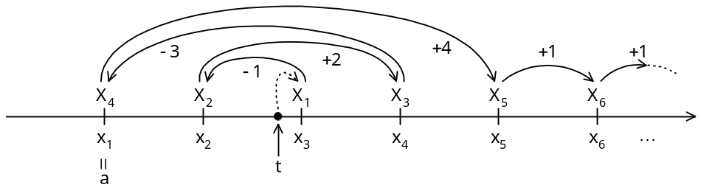
Fig. 1 Numbering of Sample Points by "arrange" Subroutine

(5) The interpolated value “P(t)” for “t” is derived by constructing a polynomial expression “P(X)” for “X” that satisfies “P(X_{j}) = Y_{j}.” The “(k-1)th” order polynomial expression that satisfies all “k” sample points is expressed as follows:

Pk(t) = | (t − X2) (t − X3) … (t − Xk) | Y1 + | (t − X1) (t − X3) … (t − Xk) | Y2
Pk(t) = | (X1 − X2) (X1 − X3) … (X1 − Xk) | Y1 + | (X2 − X1) (X2 − X3) … (X2 − Xk) | Y2

+ … + | (t − X1) (t − X2) … (t − Xk−1) | Yk
+ … + | (Xk − X1) (Xk − X2) … (Xk − Xk−1) | Yk

Because the set of sample points “(X₁, X₂, ..., X_{k})” is used in the above expression, this expression is labeled “P_{k},₁(t).” An interpolated value that was derived from the set of sample points “(X_{j}, _{Xj+1}, ..., X_{j+k-1})” is expressed as “P_{k},_{j}(t).”
(6) When “k = 1,” the value of the “(k-1)th” order polynomial expression “P₁,_{j}(t)” is the constant “Y_{j}.” When “k = 2,” the value of the “(k-1)th” order polynomial expression “P₂,_{j}(t)” is a first order expression using the sample point set “(X_{j}, X_{j+1}).” Similarly, when “k = m,” the value of “P_{m},_{j}(t)” is an “(m-1)th” order expression using the sample point set “(X_{j}, X_{j+1},...,X_{j+m-1}).” The following relational expression can be derived from these polynomial expressions:

Pr+1, k-r(t) = | (Xk − t) Pr, k-r (t) − (Xk-r− t) Pr, k-r+1 (t) | (1 ≤ r ≤ k − 1)
Pr+1, k-r(t) = | Xk − Xk-r | (1 ≤ r ≤ k − 1)

(7) Based on the expressions shown in (6), it is possible to derive “P₂,₁(t)” from “P₁,₁(t)” and “P₁,₂(t).” By using “P₁,₃(t)” next, it is possible to derive “P₂,₂(t)” and “P₃,₁(t).” As a result, the value “P_{k},₁(t)” gives the interpolated value for f(x) at x = t, based on its values at the k sample points.
(8) The procedure described in (7) is repeated while the number of sample points “k” that are used is increased, until the end condition “EPS > | P_{k},₁(t) - P_{k-1},₁(t) |” is satisfied. Here, EPS is a small value that is given beforehand. Once the end condition is satisfied, the program displays the interpolated result and the number of sample points that were used and then terminates. If “k = KMAX” is reached and the end condition has still not been satisfied, the program displays an error message and then terminates.

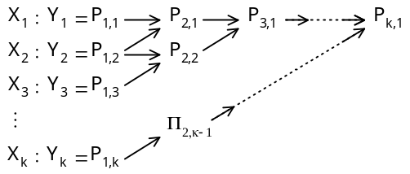
Fig. 2 Iterative Interpolation Method
[Program]

program interpolate
integer, parameter :: NMAX=100, KMAX=10
real, parameter :: EPS=1.0e-5
real, dimension(NMAX) :: x, y
real, dimension(NMAX,KMAX) :: p
integer, dimension(NMAX) :: idx
integer :: i, near, k, n
real :: t, prev

call sample(n,x,y) ! Loads the function table
read(*, *) t
call find(n,x,t,near) ! Finds the point closest to “t”
call arrange(n,x,t,near,idx) ! Orders the sample points and function values
do i=1,KMAX
p(1,i)=y(idx(i))
enddo
prev=p(1,1)
do k=2,KMAX
do 
p(i+1,k-i)= () / (x(idx(k))-x(idx(k-i)))
enddo
if(abs(p(k,1)-prev) < EPS) then
write(*,'(a,f10.5,a,i3)') 'value: ', p(k,1), ', step: ', k
stop
else
prev=p(k,1)
endif
enddo
write(*, *) 'ERROR: not converged'
contains
subroutine arrange(n,x,t,near,idx)
integer :: n, near, i, j, k, m
real, dimension(:) :: x
integer, dimension(:) :: idx

idx(1)= near
if(t >= x(near)) then
i=1
else
i=-1
endif
do m=2,n
k=idx(m-1)+i
if(k <= 0) then
i=1
exit
else if(k > n) then
i=-1
exit
else
idx(m)=k
endif
i=  ! “sign(A,B)” is the absolute value of “A” with the sign of “B”
enddo
do 
idx(j)=idx(j-1)+i
enddo
end subroutine arrange
end program interpolate

Sub-Question
Select the correct answers to be inserted into the corresponding boxes () in the above program from the choices provided below.

Answer group for a:
a) i=1,k-1 b) i=1,k c) i=1,k+1
d) i=2,k-1 e) i=2,k f) i=2,k+1

Answer group for b:
a) (x(idx(k))-t) *p(i,k-i)+(x(idx(k-i))-t) *p(i,k-i+1)
b) (x(idx(k))-t) *p(i,k-i)-(x(idx(k-i))-t) *p(i,k-i+1)
c) (x(k)-t) *p(i,k-i)+(x(k-i)-t) *p(i,k-i+1)
d) (x(k)-t) *p(i,k-i)-(x(k-i)-t) *p(i,k-i+1)

Answer group for c:
a) sign(abs(i),-i)
b) sign(abs(i)+1,-i)
c) sign(abs(i)-1,-i)
d) sign(abs(i),i)
e) sign(abs(i)+1,i)
f) sign(abs(i)-1,i)

Answer group for d:
a) j=1,n b) j=2,n c) j=m-1,n
d) j=m,n e) j=m+1,n

